

**INSTITUTE OF TECHNOLOGY OF CAMBODIA**

DEPARTMENT OF INFORMATION AND COMMUNICATION ENGINEERING

**PROJECT REPORT ON**

**“Coffee Shop Management System”**

**Under The Guidance Of:**

Lecturer. BOU Channa

Team Members:

Hai Mengkuong ID: e20180236

Hal Sokheang ID: e20180244

Han Kimhak ID: e20180248

Hang Monyratanak ID: e20180252

Heang Sopagna ID: e20180259

Hel Sokheng ID: e20180266

**Table of Contents**

1. Introduction………………………………………………………………………...........3

2. Team Structure……………………………………………………………………..........3

3. Project Description………………………………………………………………………4

4. Flow of program ……………………………..…………………………………………6

5. Task Responsibilities……………………………………………………………………8

6. Functionalities of Program ……………………………………………………………...9

7. Data Type use………………………………………………………………………….15

8. Results………………………………………………………………………………….15

9. Conclusion……………………………………………………………………………..16

10. Problem Faced and Difficulties…………………………………..……………………16

11. Team Meeting History…………………………………………………………………17

**1. Introduction**

How many times did you drink coffee? Did you know what kind of system will be used or how important they are on coffee shop? Nowadays, the number of coffee shop is increasing look like the mushroom. It became more and more popular for the favorite place for meeting or enjoys the coffee. Some of them go to coffee shop every day or only on their holiday. But some time they just are there for their business. It is also make a ton of work opportunity to get the experience by being their employee. The programmers has been used some of the function or method to create the great system for the employee. It became more helpful and easy to set the Information under control. After reading this report of this coffee shop system, you might get more knowledge about the some of the function that programmer may use on at coffee shop. For example, some of the functions that can control the information of the coffee order that you always saw them used by the cashier, the information of the stock that the manager used to look after in every day, month or year. Moreover the employee’s information is also important and used at every coffee shop. For example, their salary, their personal information. Hope it will help to solve your problem if you have to work on this system too.

**2. Team Structure**

**Leader**

Hang Monyratanak

**Sub-Leader**

Heang Sopagna

**Member**

Hai Mengkuong

**Member**

Hal Sokheang

**Member**

Han Kimhak

**Member**

Hel Sokheng

* Hang Monyratanak : role as leader of the team vote by all 5 members. He is a kind person, friendly and easy going. He has a skill to adapt in any situations with the harmony of views.
* Heang Sopagna : role as sub-leader in the team that promote from leader and also agree from all 4 members.
* Hai Mengkuong : role as a member in the team. He is a kind of friendly person with an intelligent skills of communications and also hard working.
* Hal Sokheang : role as a member in the team. He is a friendly person with responsibility.
* Han Kimhak : role as a member in the team. He is a friendly person with responsibility and have a lot of good ideas and advice.
* Hel Sokheng : role as a member in team. He also a friendly person with creative idea.

**3. Project Description**

Our project is working on Coffee Shop System that can help the owner to improve ordering system and service, better customization of product and stock administration. This program also maintains the record related to ordering, billing, beverages and employee details, timekeeping, and total income.

* **Ordering system:**

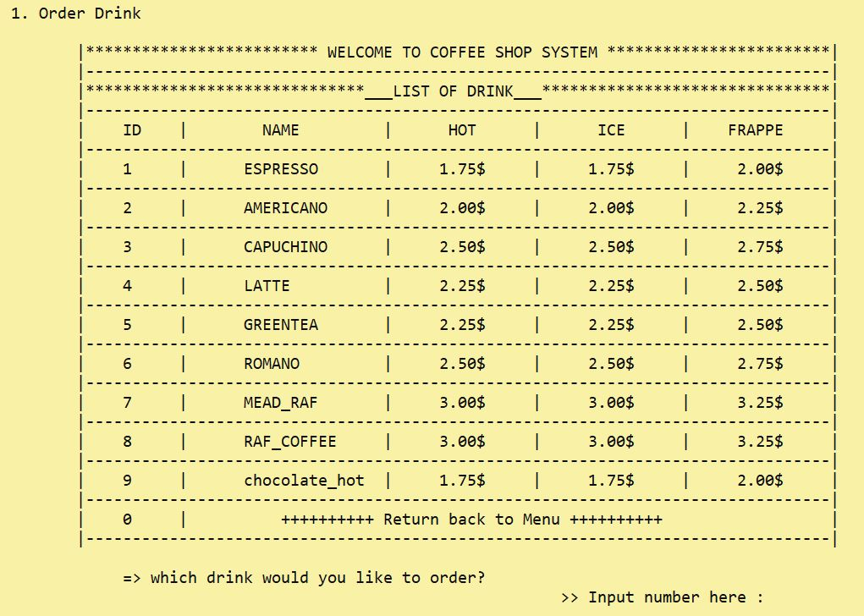 The main point of ordering system is to provide the customers with a facility to place their order through this program. Customers can easily browse all the beverages available in the coffee shop.

* **Stock administration:**

For management the stock such as check stock available, add new stock of drink, add new product or edit or delete the product information as well.

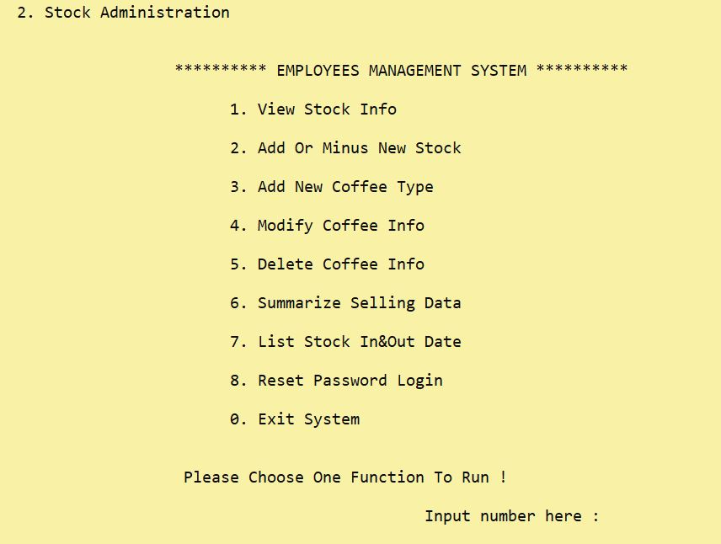

* **Employee administration:**

It shows employee information, we also can add, modify or delete the employee information. For security purpose, it requires password to access all the options below.

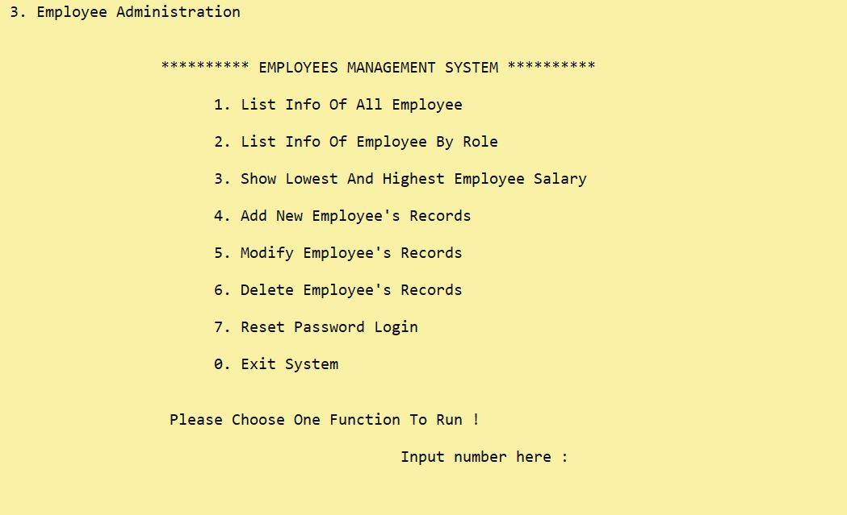

**4. Flow of program**

* **Program start**

**Coffee Shop System**

**Exit**

**Employee Administration**

**Stock Administration**

**Ordering System**

**Process**

**Process**

**Process**

When the program start the console will display this three main function systems. And it ask user to choose one of this main function system to operate.

* **Ordering systems**

**Coffee Shop System**

No

**Ordering System**

Yes

**Return**

* Order drink
* Check stock for order
* Confirm the order
* Ask for VIP discount
* Display receipt
* Do payment
* Ask for another order

After choose the function ordering system to operate the program will display the coffee information and ask customer to place an order (type of coffee and quantity), then the program will check stock for amount of quantity order above. After that, the program will ask the customer to confirm their order to make sure the order are right. Then program will customer to find VIP card for 15% discount. After that, program will display the receipt for order and ask customer to do the payment. At the end, program will ask customer to see if they want to make an order again or not? If they want the program will repeat again and if not the program will return to main function systems.

* **Stock administrations**

**Return**

**Coffee Shop System**

**Process**

1. View stock
2. Add or minus stock
3. Add new coffee
4. Modify coffee info
5. Delete coffee info
6. Summarize selling data
7. List stock in & out date
8. Reset password

0. Exit

**Stock Administration**

**Password request**

After choose the function stock administrations system to operate the program will request the password to log into the program. If the password enter correct, the program will show a list of function to choose for operating. After do the operation the program will return to the list of menu function again. At the end, if user input the “exit” function, the program will return to main function systems.

* **Employee administrations**

**Return**

**Password request**

**Coffee Shop System**

**Process**

**Employee Administration**

1. List employee info
2. List employee info by role
3. Show lowest & highest employee info
4. Add employee info
5. Modify employee info
6. Delete employee info
7. Reset password

0. Exit

Similarly to the function stock administrations system, the function employee administration system will request the password to log into the program. If the password enter correct, the program will show a list of function to choose for operating. After do the operation the program will return to the list of menu function again. At the end, if user input the “exit” function, the program will return to main function systems.

**5. Task Responsibilities**

There are 3 main function in the program and a few small function for design interface.

The first function is Ordering systems. And there are 11 small functions for support in this system. The member who responsible for this function are : Heang Sopagna and Hai MengKuong.

The second function is stock administration systems. And there are 7 small functions for support in this systems. The member who responsible for this function are : Hang Monyratanak and Hal Sokheang.

The third function is employee administration systems. And there are also 7 small functions for support in this systems. The member who responsible for this function are : Han Kimhak and Hel Sokheng.

The small function for design interface, there are 5 functions for all.

For overall, there are 33 functions if include with the main function in this project coffee shop systems.

**6. Functionalities of Program**

1. **Functions for ordering system**

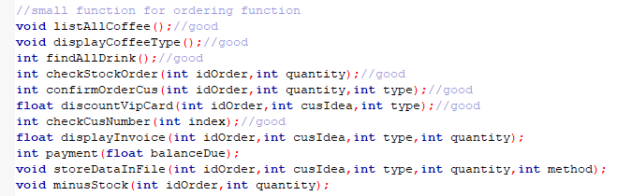

* 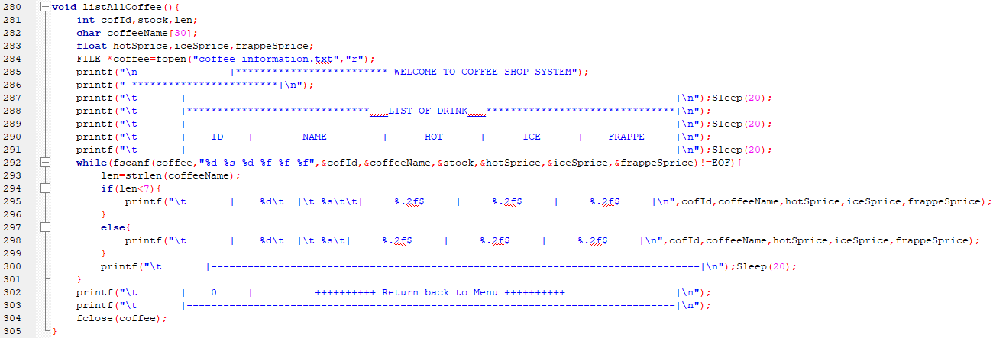**Void listAllCoffee ( ) ;**

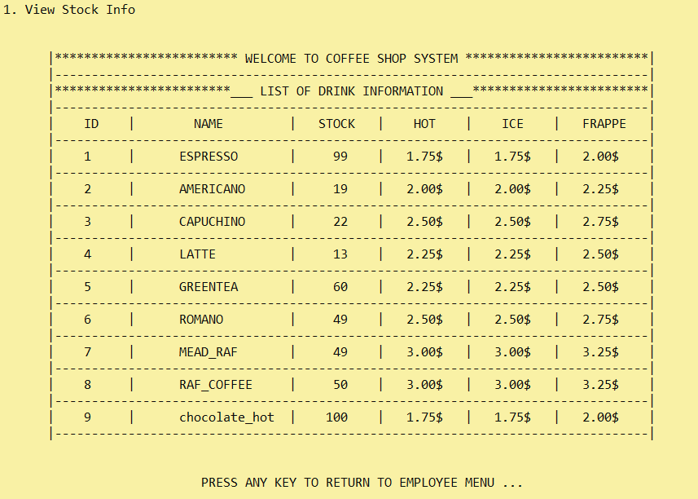

* 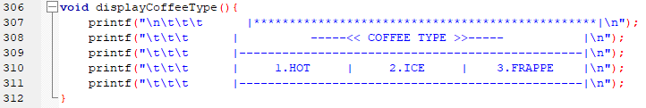**Void displayCoffeeType ( ) ;**

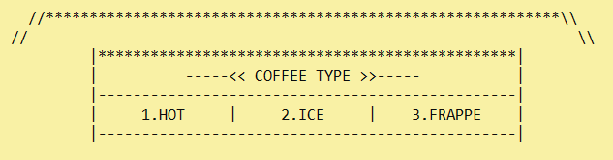

* 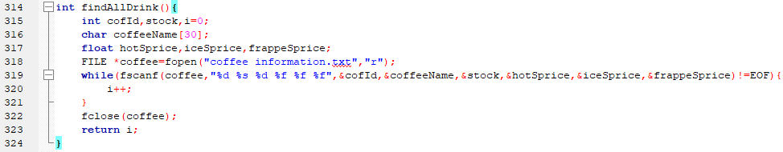**Int findAllDrink ( ) ;**

This function is to keep track of the number of last drink id or find the total number of all coffee type for use in another functions. This function work as the kind of support function.

* 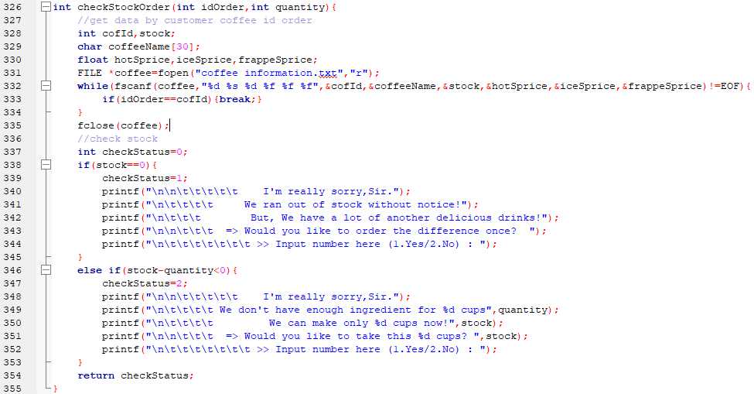**int checkStockOrder ( int idOrder , int quantity ) ;**

* 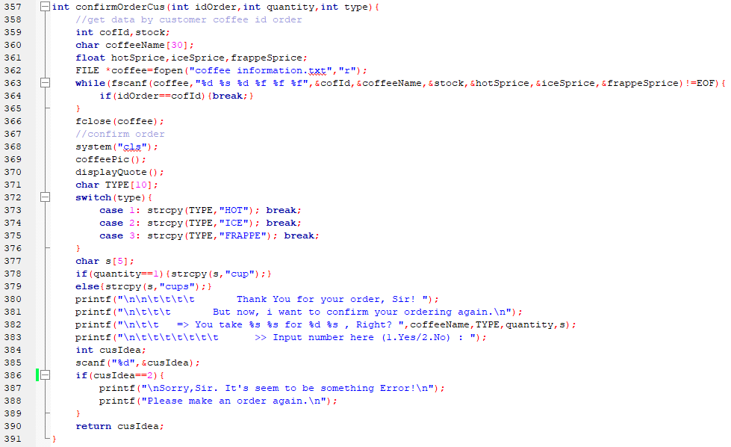int confirmOrderCus(int idOrder,int quantity,int type);
* 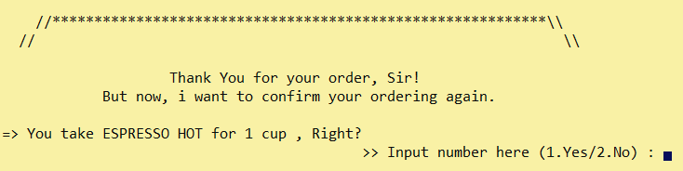
* 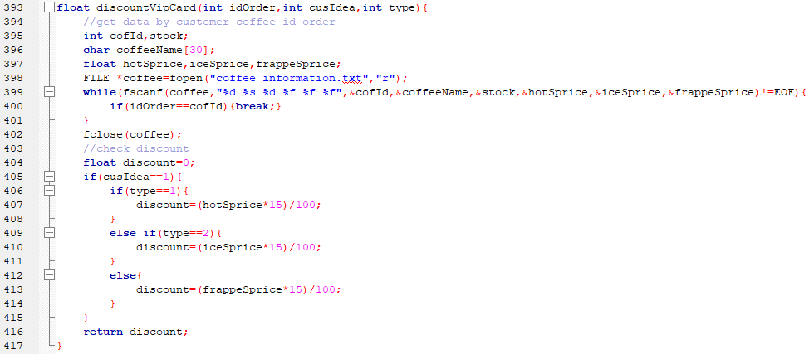 **float discountVipCard(int idOrder,int cusIdea,int type);**

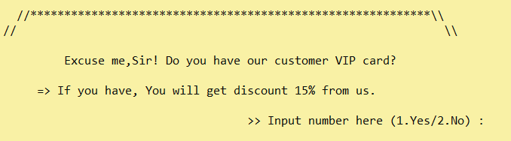

* 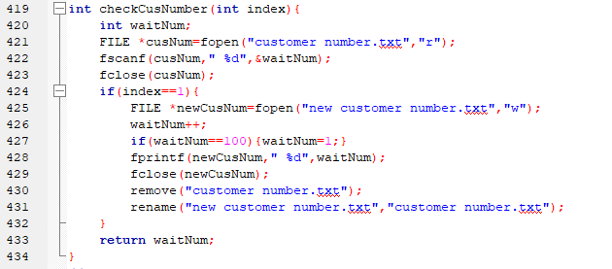**int checkCusNumber(int index);**

This function is to keep track or find the number of customers. It is a support function.

* **float displayInvoice(int idOrder,int cusIdea,int type,int quantity);**
* **int payment(float balanceDue);**
* **void storeDataInFile(int idOrder,int cusIdea,int type,int quantity,int method);**
* **void minusStock(int idOrder,int quantity);**

This function’s code is a bit too long. Please check the code program to see more detail of information (line 435 – 492, line 493 – 526, line 527 – 551, line 552 - 573).

* **void orderCoffee();**

This function is one of the main function that operate the whole process of ordering system. Please check the code program to see more detail of information (line 573 - 737).

1. **Function for Stock administration system**

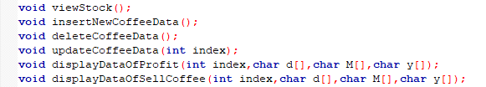

* **Void viewStock();**

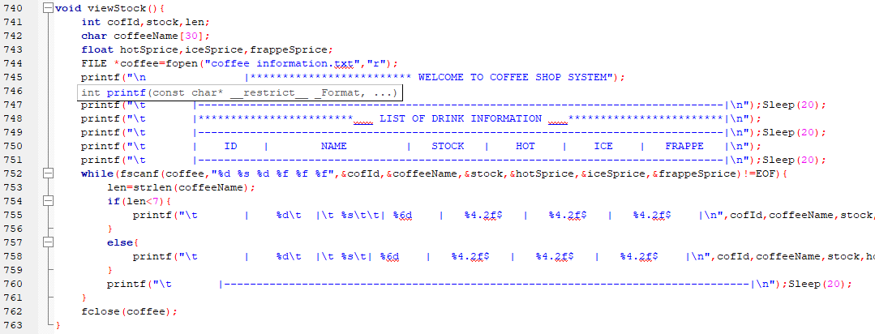

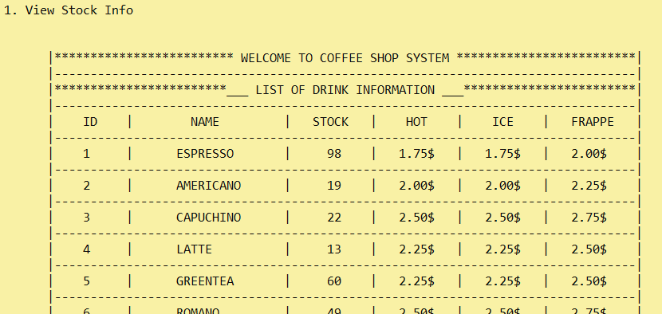

* 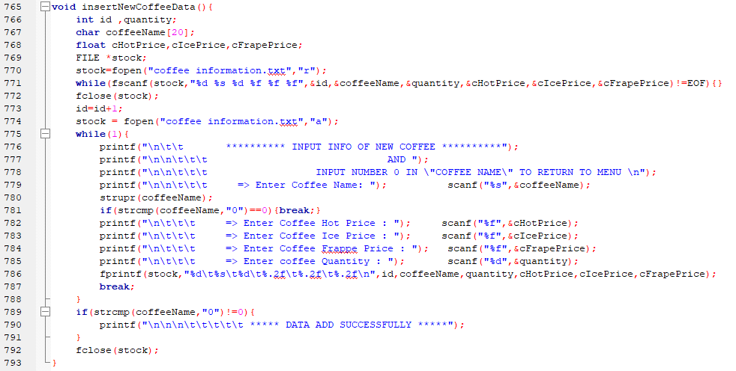**void insertNewCoffeeData();**

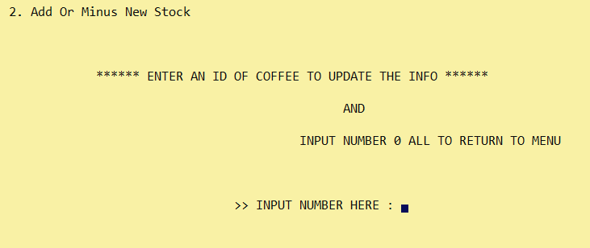

* **void deleteCoffeeData();**
* **void updateCoffeeData(int index);**
* **void listStockInOutDate();**
* **void displayDataOfProfit(int index,char d[],char M[],char y[]);**
* **void displayDataOfSellCoffee(int index,char d[],char M[],char y[]);**

This function’s code is a bit too long. Please check the code program to see more detail of information (line 794 – 833, line 834 – 900, line 901 – 912, line 913 – 950, line 951 - 1000).

* **void stockAdministration(char function[]);**

This function is one of the main function that operate the whole process of ordering system. Please check the code program to see more detail of information (line 1001 - 1104).

1. **Function for employee administration systems**

Function for employee administration systems are similarly to the stock administration system, the flow and structure of code are similar. Please check the code program to see more detail of information (line 1001 - 1104).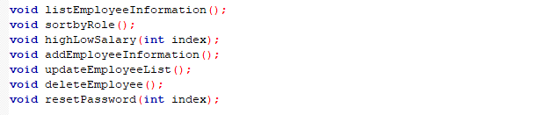

**7. Data type used**

In this project, we only use the simple data type such as :

* Character (char )
* String ( char )
* Integer ( int )
* Float ( float )

**8.** Results

* + Code completed as planned
  + Teamwork and communication went well
  + The project finished in time
  + Team members had good responsibility for their tasks and assigned the work punctually
  + Team members had high commitment to do the project
  + everyone always participate in the meeting and discussion via Telegram and Microsoft Team as well as meeting in presence

**9. Conclusion**

During doing this topic, we forced with some problems, we always do a research to solve the problem point for the topic. Some feature is difficult to write. One more, we have online meeting and offline meeting most of the online meeting we met via the Microsoft Team and offline we met at school. We tried to make a meeting as much as possible to discuss about our topic. All the problem we forced, we tried to solve it step by step and one by one as fast as possible. All the member act working as group, we kept solidarity and patient. We kept going on however we met the obstacle ahead. All member tries to do the point that they response to and gave the feature on the date we determinate. Almost a month that we work together with a lot of experiences we reached to finish the project as we expected.

Finally, we want to say congratulation and thanks to our team for finishing the project. We would like to say thanks to teacher who always give us a lot of advices and guide the direction to do the project until we can finish it as well.

**10. Problem Faced and Difficulties**

* adding , delete
* create password when we input wrong dataType and ask them again.
* Error code and take time for dealing a problem.
* Space Character
* Combine code take time to edit.
* Interface design
* before do project didn't know about array and function and after done project get to know it well.

**11. Team Meeting History**

**24/12/2020 : start making microsoft team and telegram for discussing**

**29/12/2020 : divided indiviual member which responsible to do work**

**09/01/2021 : facing problem and discussing in microsoft team**

**10/01/2021 : dicussing about design interface and make more function on employee administration**

**15/01/2021 : meeting at ITC for dicussing to find the solution for working function employee administrator.**

**17/01/2021 : coding and meet the new problem and find solution together**

**18/01/2021 : collecting code and combine together and fixing the code.**

**20/01/2021 : editing about clock & color background after feedback from lecture**

**-26/01/2021 : do slide presentaion and report**

**-25/01/2021 : continue from the previous days**